CONSOLIDATED EXAM QUESTIONS

PROPERTIES AND STRUCTURE OF ATOMS
Contents
CONSOLIDATED EXAM QUESTIONS 1
PROPERTIES AND STRUCTURE OF ATOMS 1
Syllabus 2
Atomic Structure – 2.1-2.4 3
2017 S1 3
2017 S2 4
2020 S1 5
2020 S2 7
2023 S1 8
2023 S2 10
Mass Spectrometry - 2.4 11
2017 S1 11
2017 S2 14
2020 S1 15
2020 S2 16
2023 S1 18
2023 S2 22
Electronic Structure and Arrangement – 3.1-3.2 25
2017 S1 25
2017 S2 25
2020 S1 25
2020 S2 25
2023 S1 26
2023 S2 26
Periodic Trends – 3.2-3.3 27
2017 S1 27
2017 S2 28
2020 S1 30
2020 S2 33
2023 S1 33
2023 S2 35

Syllabus
Science as a Human Endeavour
Properties and structure of atoms
Findings from a range of scientific experiments contributed to the understanding of the atom, enabling scientists, including Dalton, Thomson, Rutherford, Bohr and Chadwick to develop models of atomic structure and make reliable predictions about the mass, charge and location of the sub-atomic particles.
Science Understanding
- elements are represented by symbols
- atoms can be modelled as a nucleus, surrounded by electrons in distinct energy levels, held together by electrostatic forces of attraction between the nucleus and electrons; the location of electrons within atoms can be represented using electron configurations
- the ability of atoms to form chemical bonds can be explained by the arrangement of electrons in the atom and in particular by the stability of the valence electron shell
- the structure of the periodic table is based on the atomic number and the properties of the elements
- the elements of the periodic table show trends across periods and down main groups, including in atomic radii, valencies, 1st ionisation energy and electronegativity as exemplified by groups 1, 2, 13–18 and period 3
- flame tests and atomic absorption spectroscopy (AAS) are analytical techniques that can be used to identify elements; these methods rely on electron transfer between atomic energy levels and are shown by line spectra
- isotopes are atoms of an element with the same number of protons but different numbers of neutrons and are represented in the form ^{A} X (IUPAC) or X-A
- isotopes of an element have the same electron configuration and possess similar chemical properties but have different physical properties
- the relative atomic mass (atomic weight), A_{r} is the ratio of the average mass of the atom to 1/12 the mass of an atom of ¹²C; relative atomic masses of the elements are calculated from their isotopic composition
- mass spectrometry involves the ionisation of substances and the separation and detection of the resulting ions; the spectra which are generated can be analysed to determine the isotopic composition of elements and interpreted to determine relative atomic mass

Atomic Structure – 2.1-2.4

2017 S1
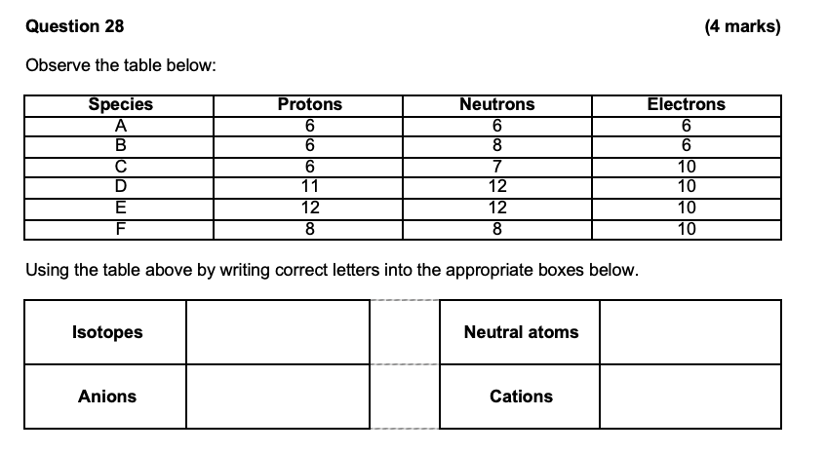
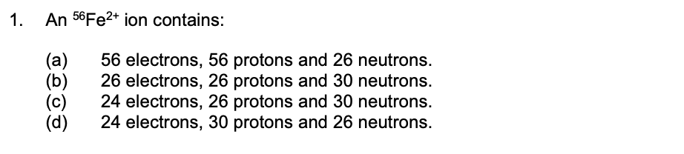
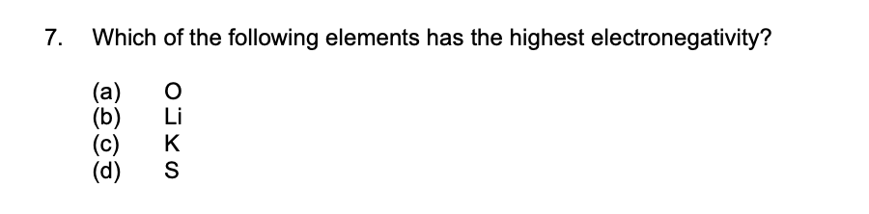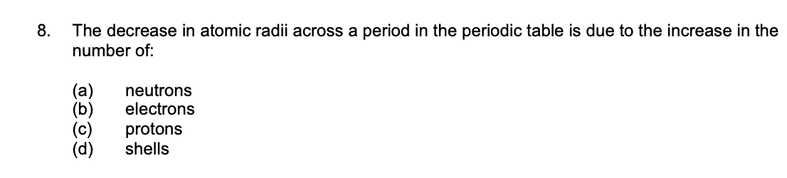

2017 S2
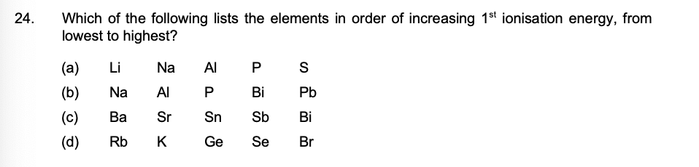

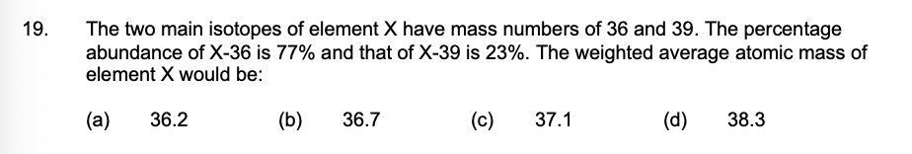

2020 S1
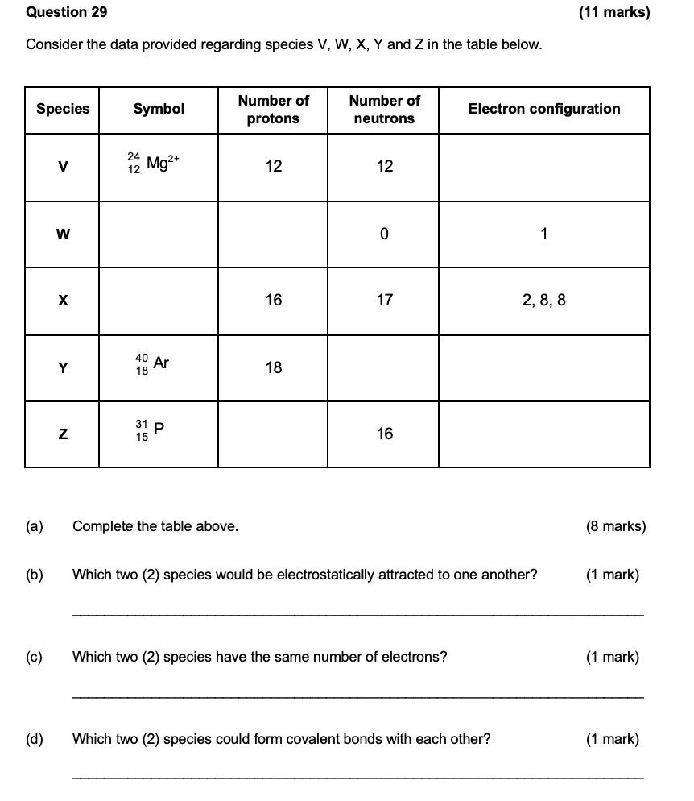
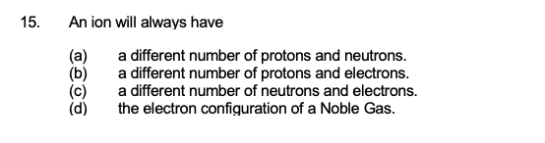
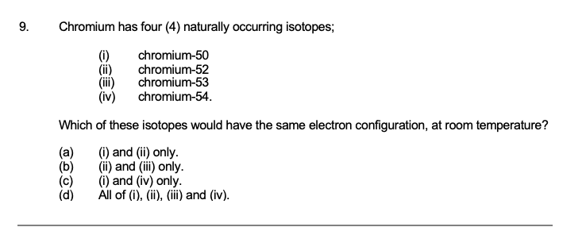
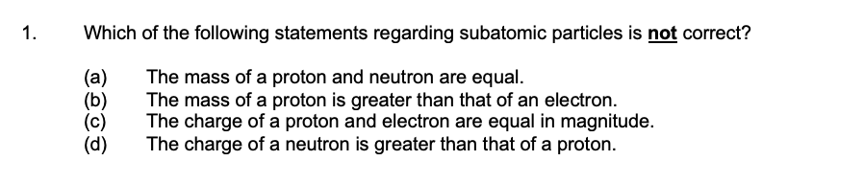

2020 S2
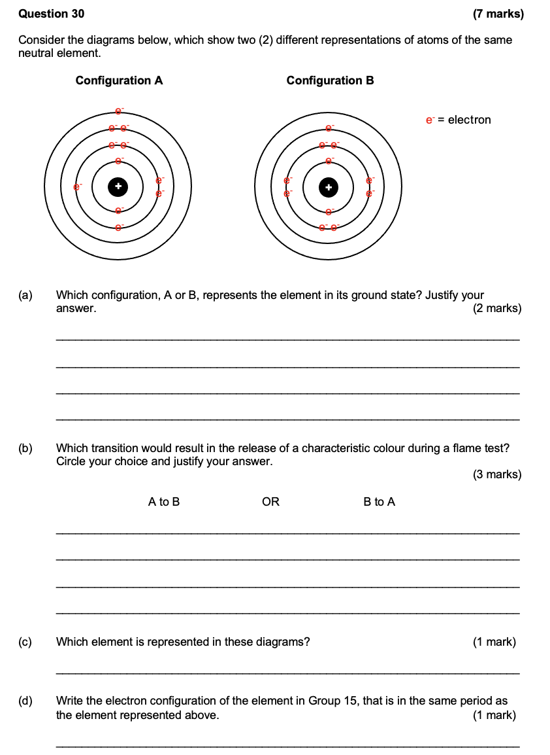
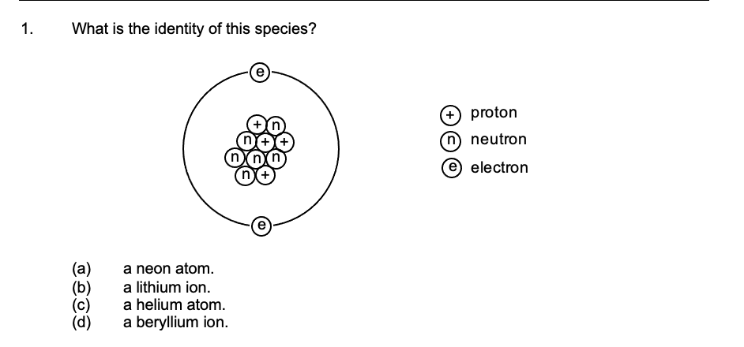

2023 S1
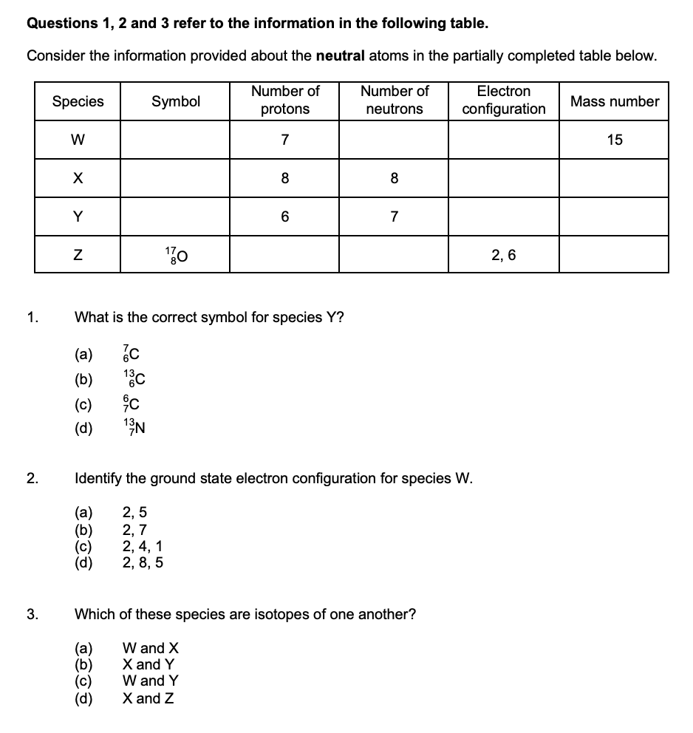
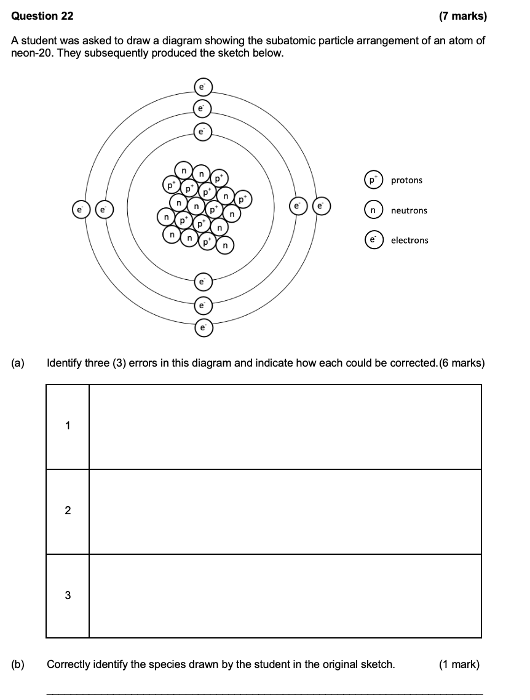

2023 S2
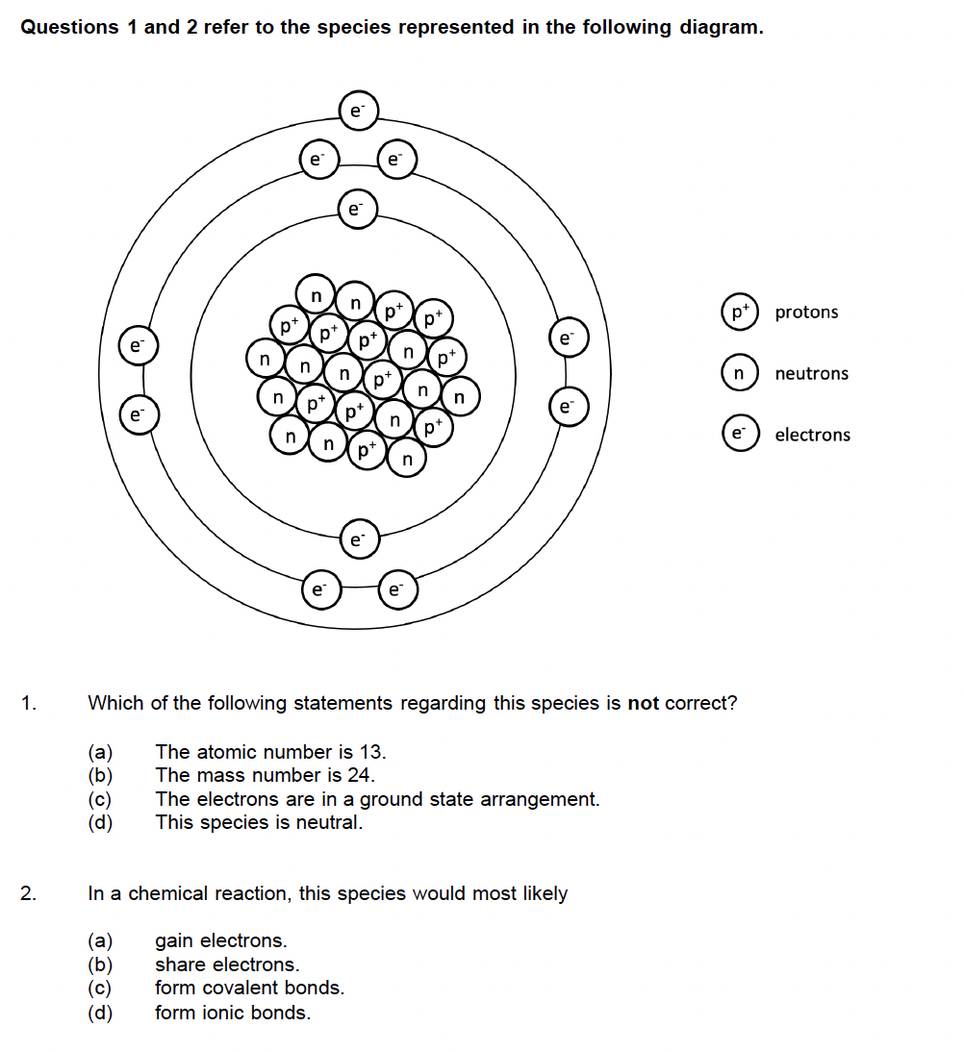

Mass Spectrometry - 2.4

2017 S1
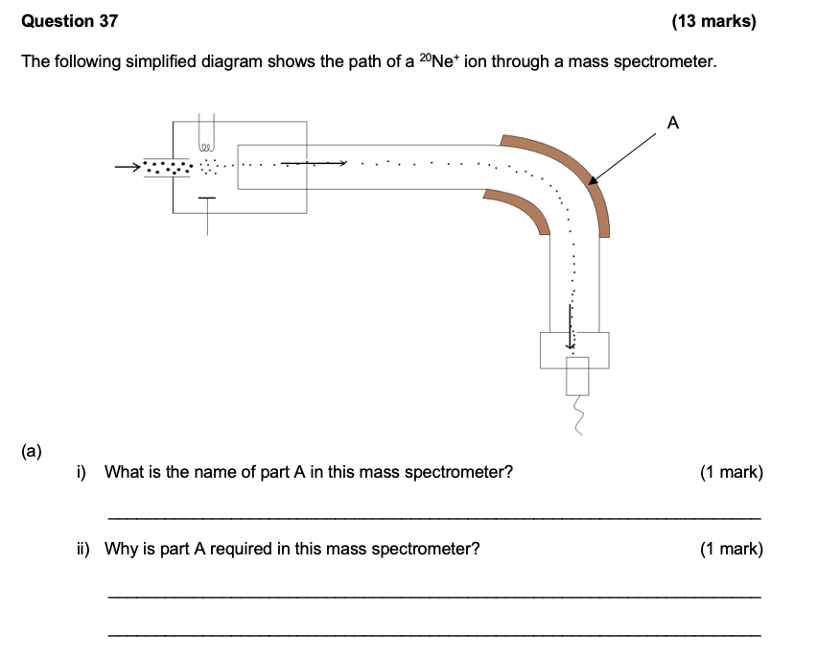
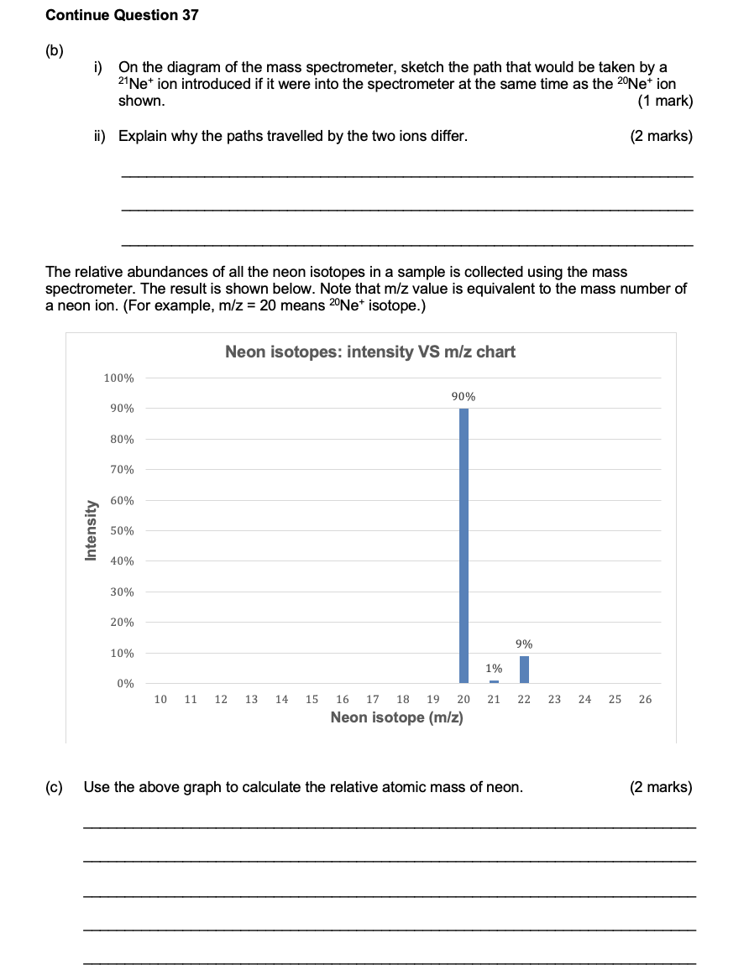
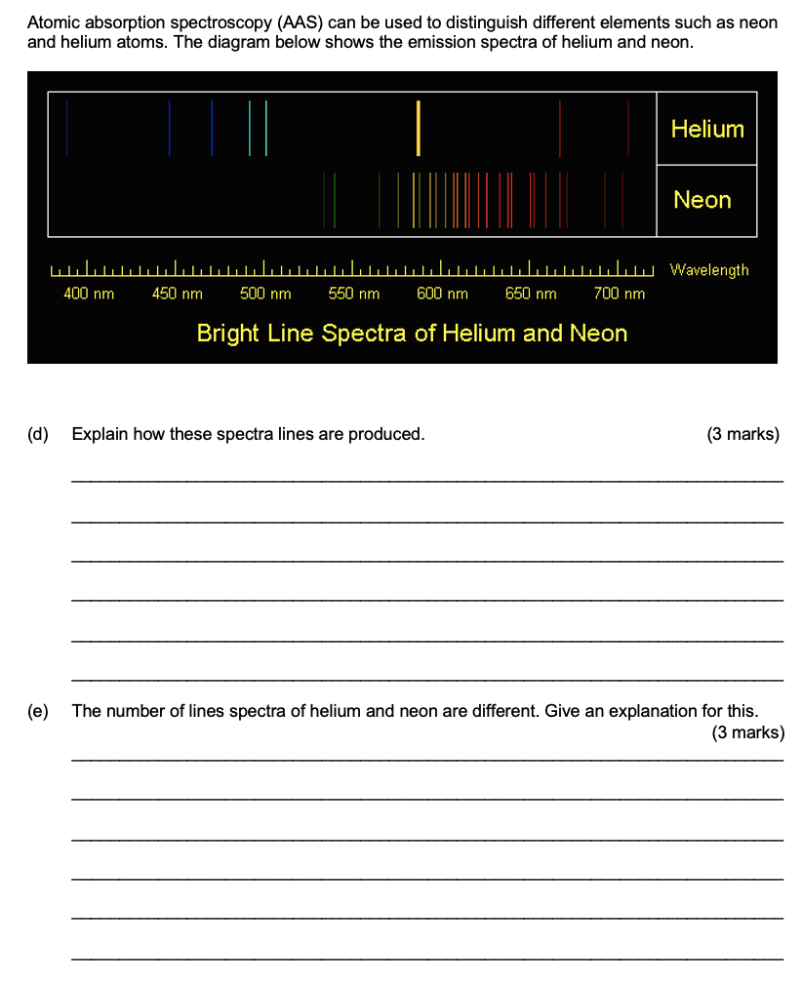
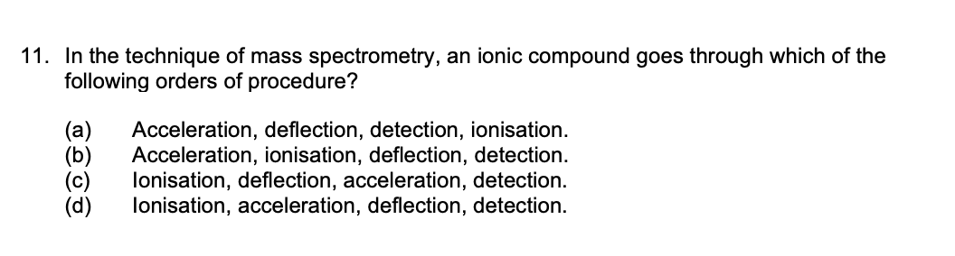

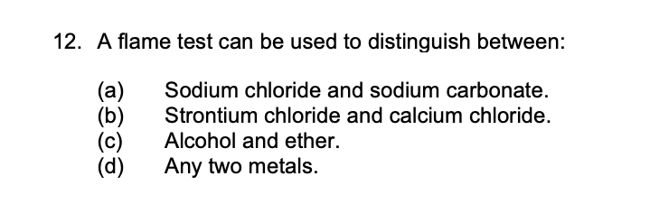
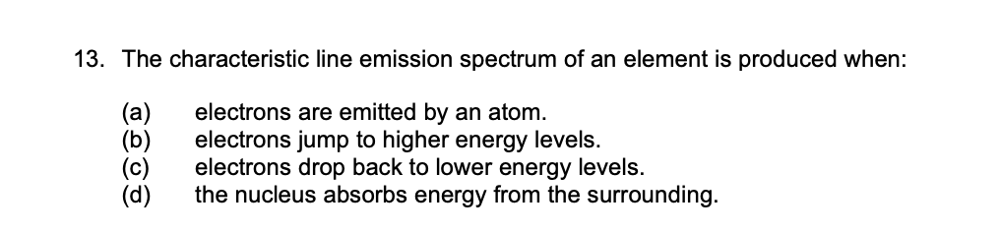

2017 S2
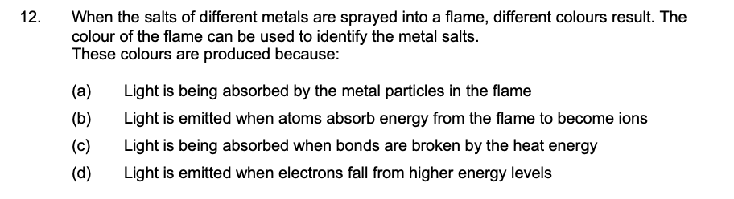

2020 S1
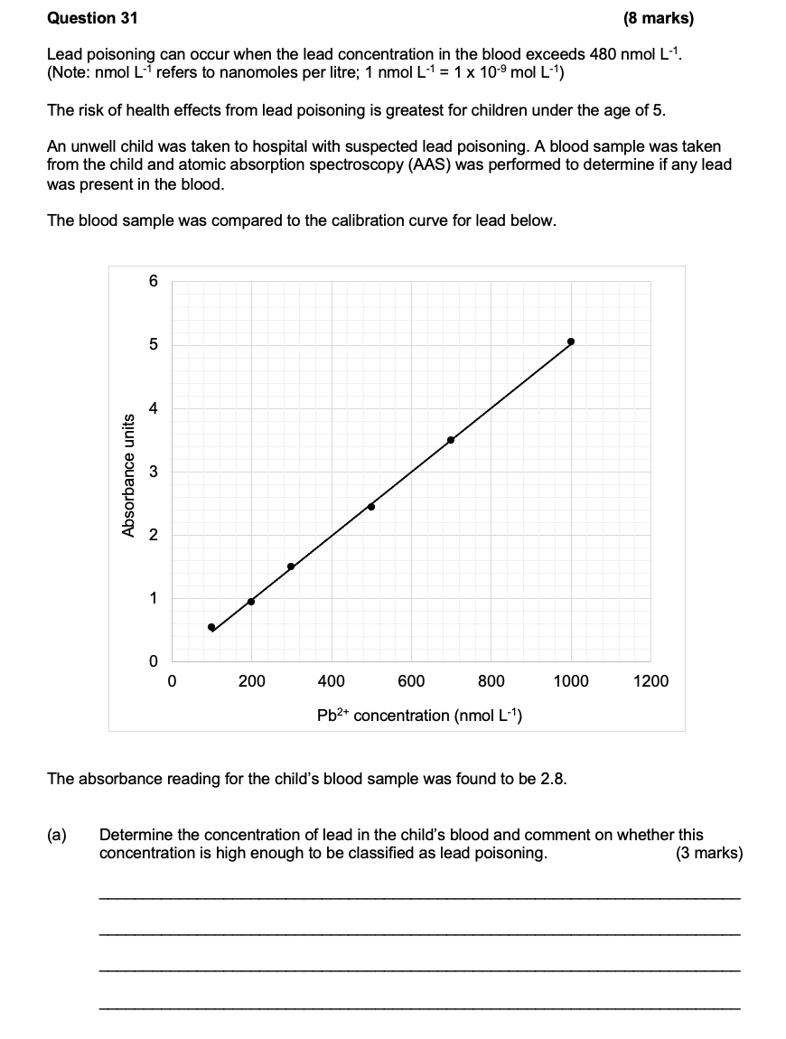
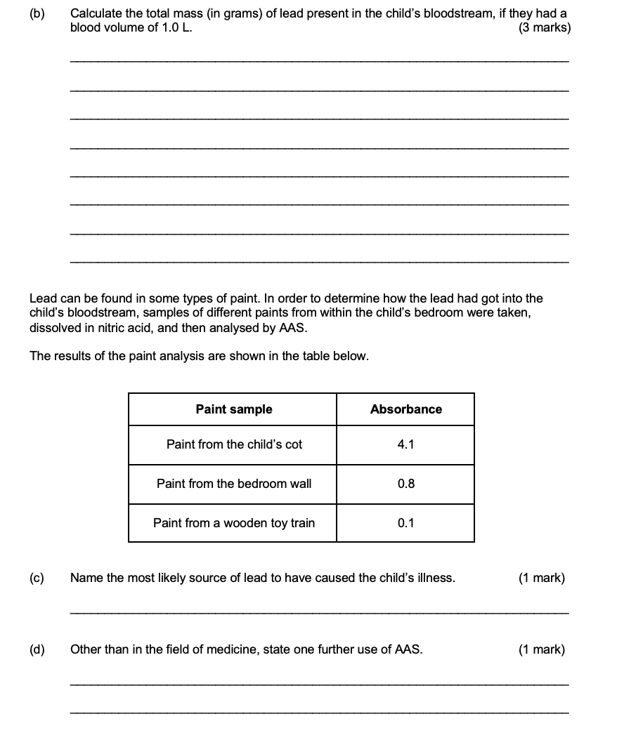
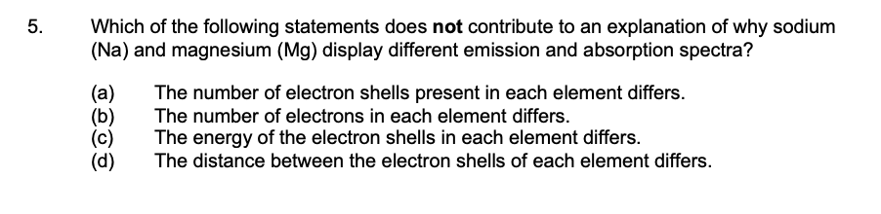
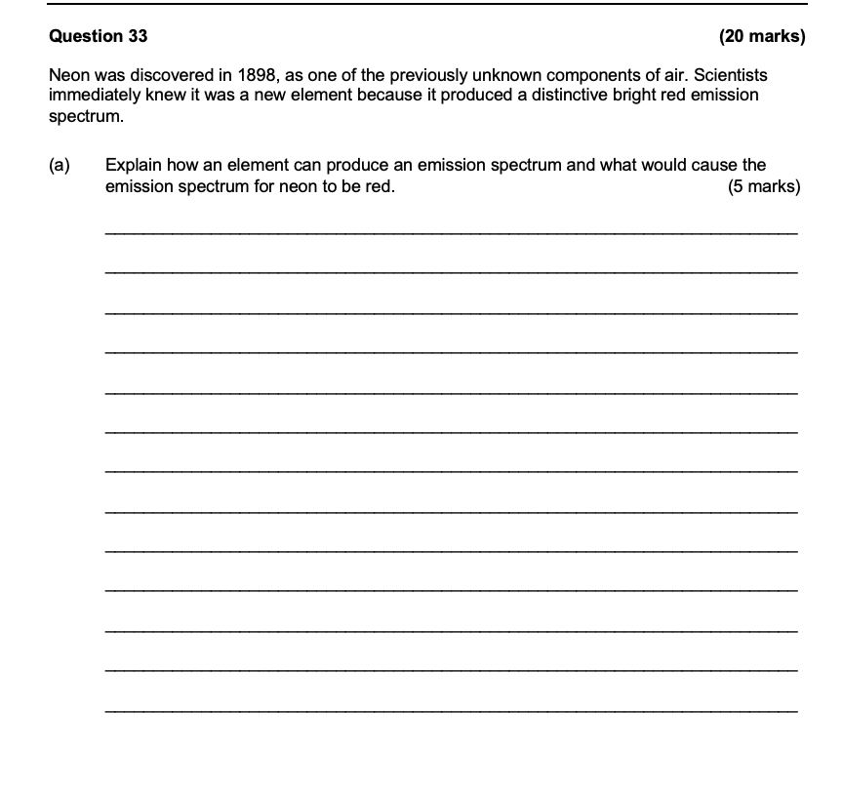
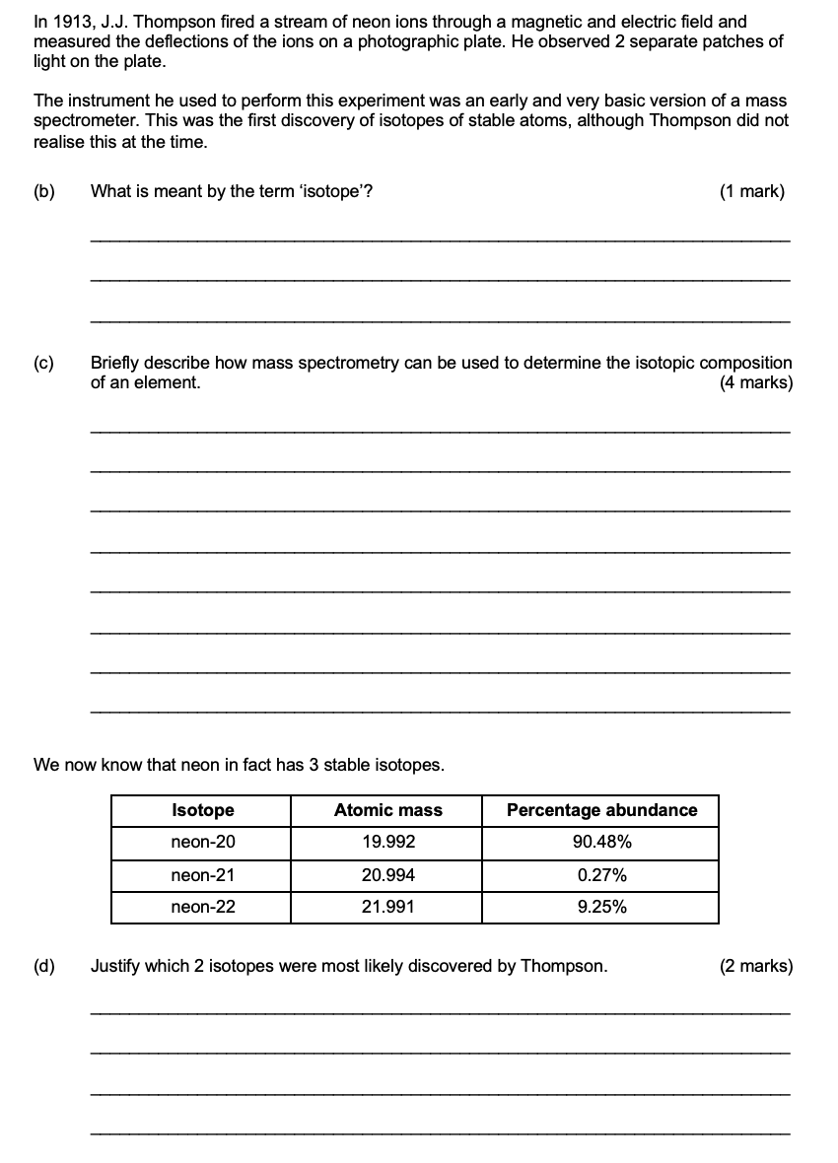
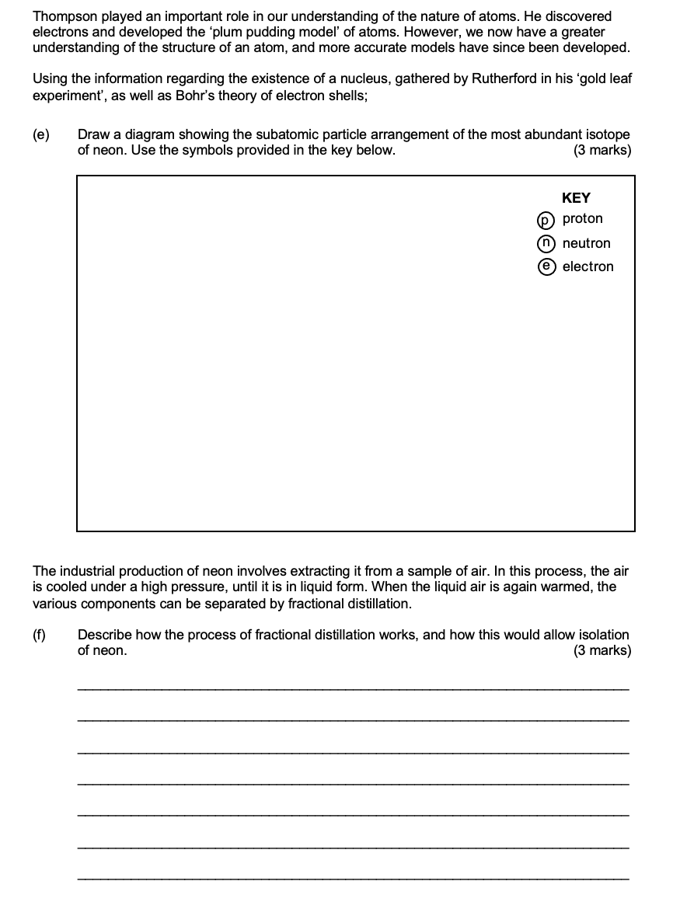
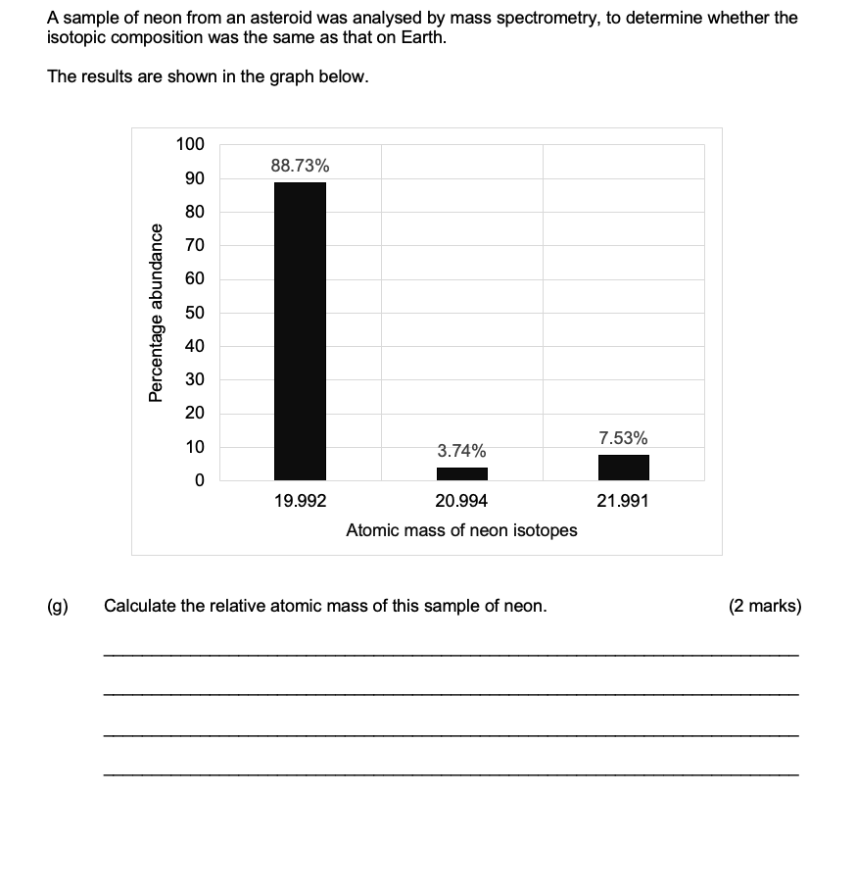

2020 S2

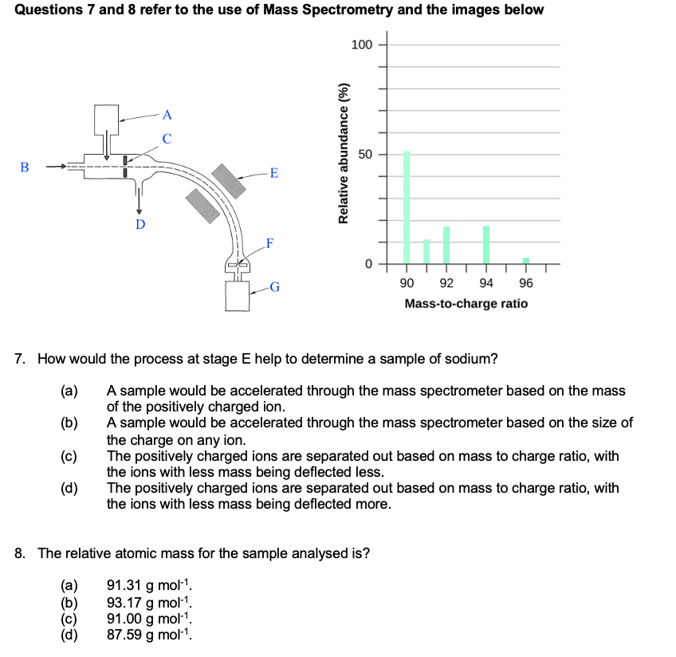

2023 S1
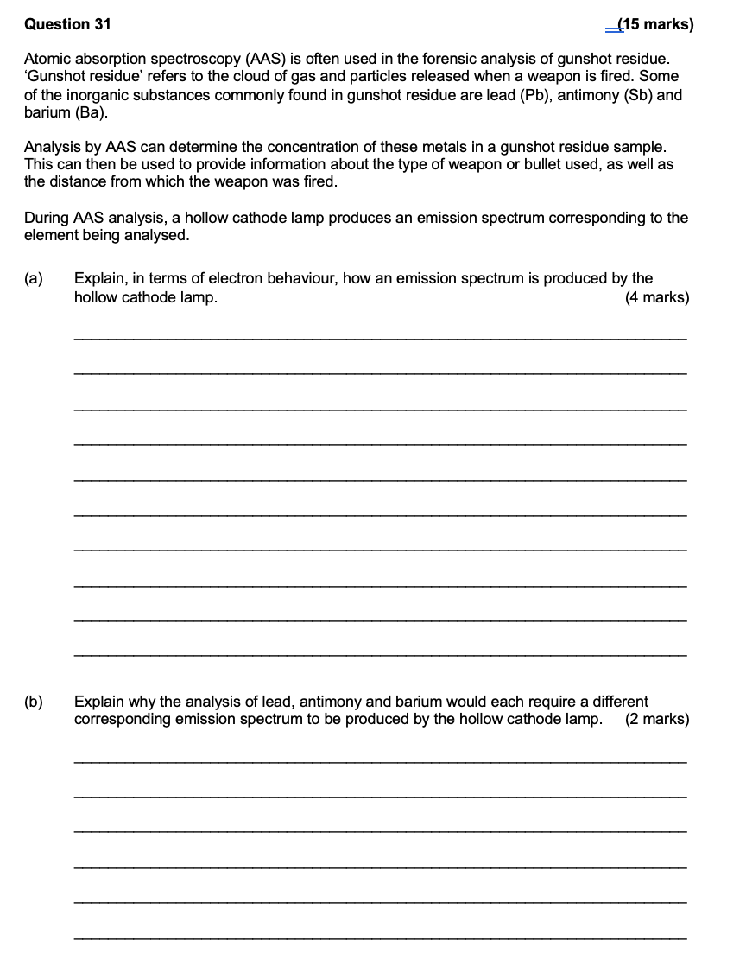
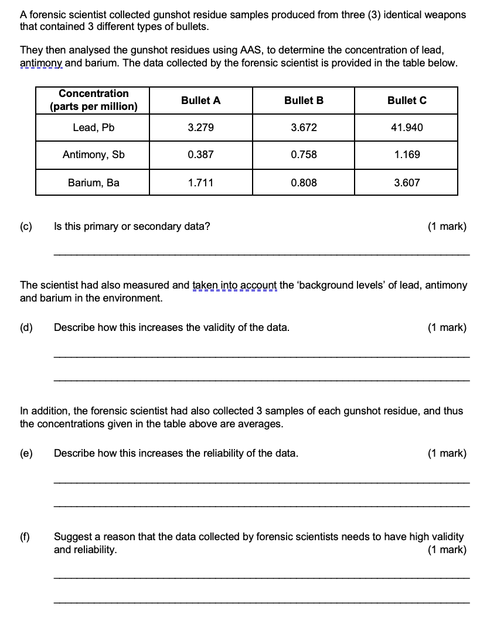
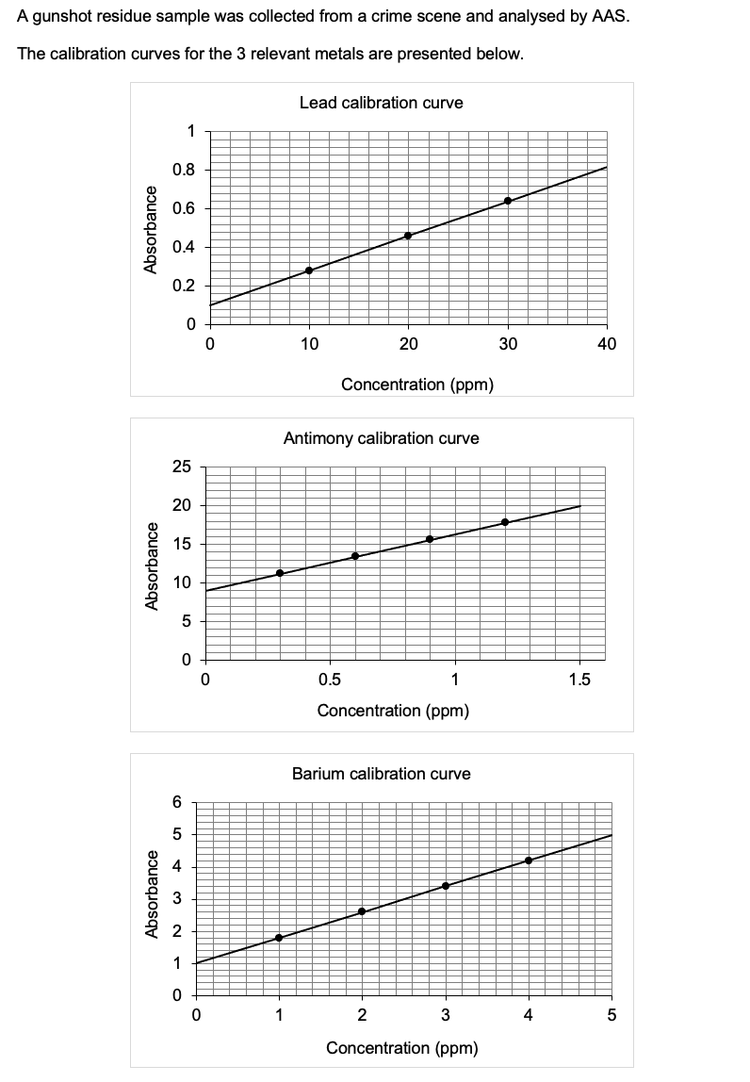

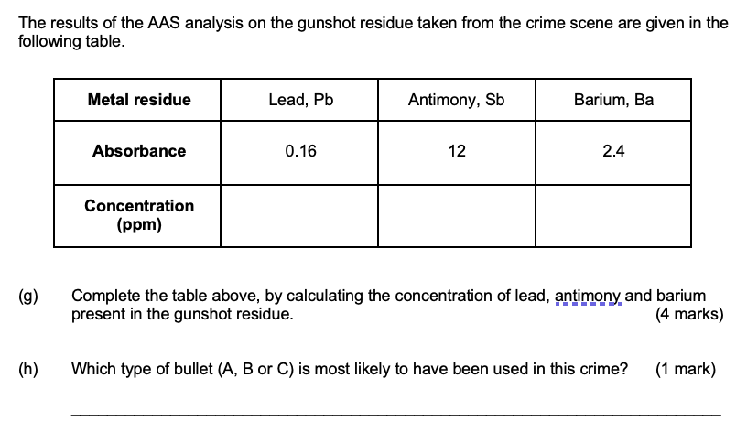
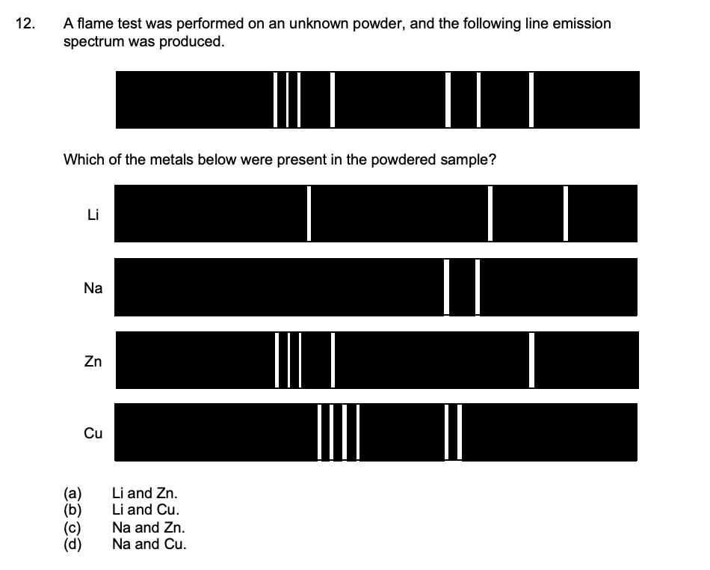
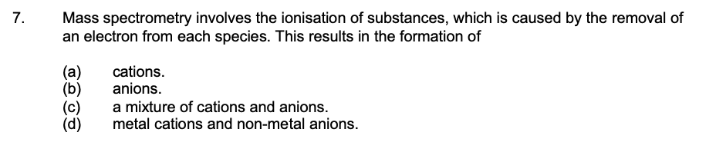
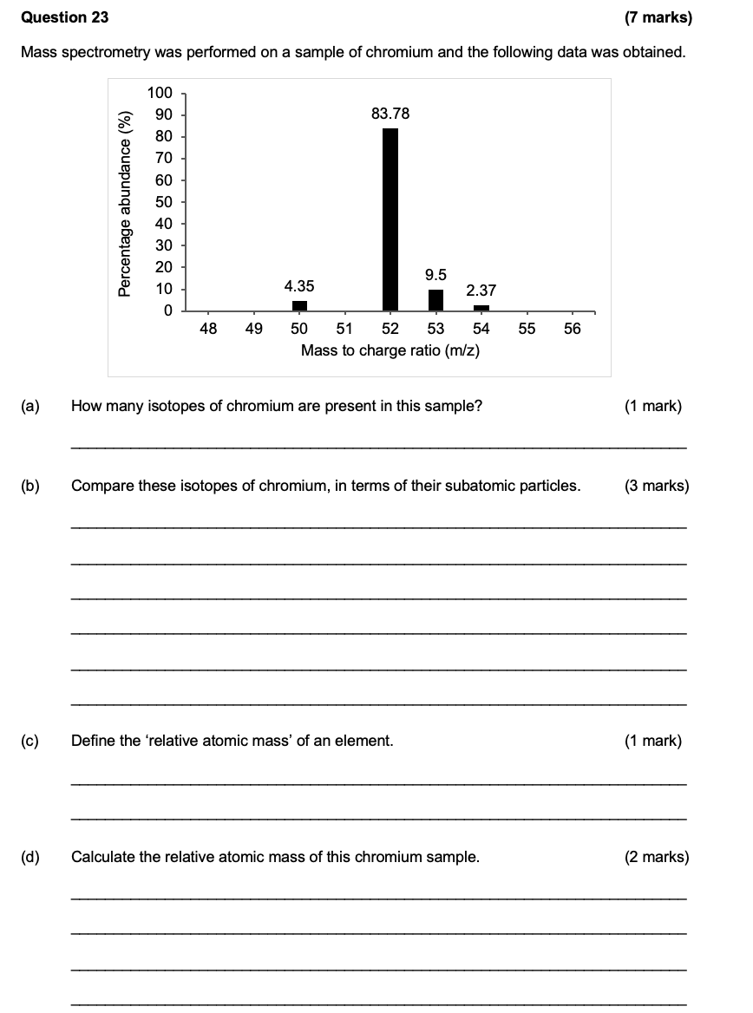

2023 S2

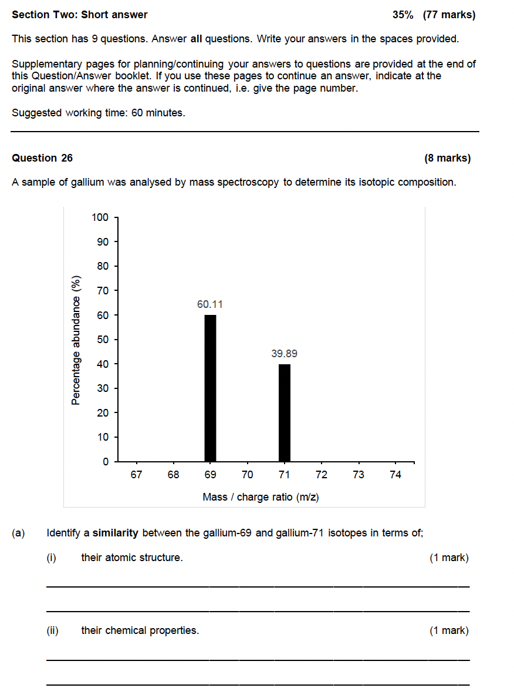
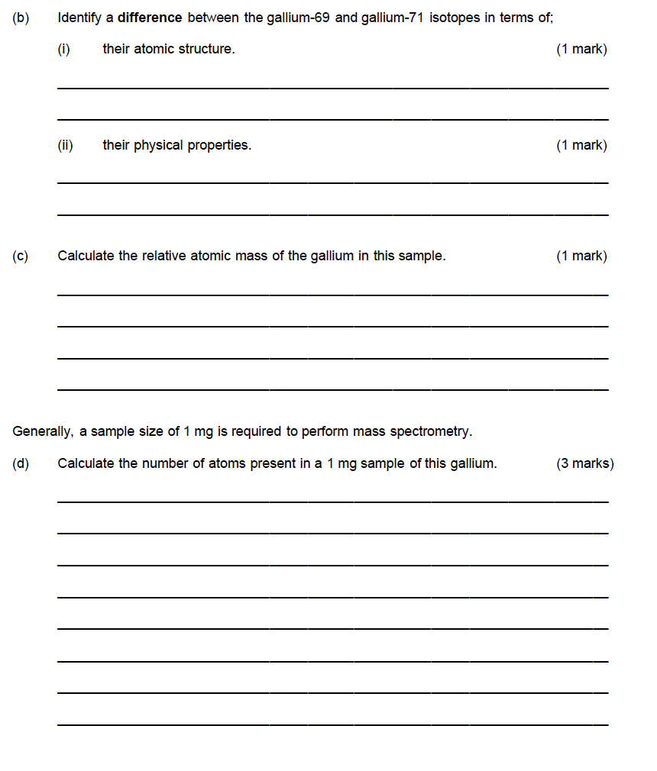

Electronic Structure and Arrangement – 3.1-3.2

2017 S1
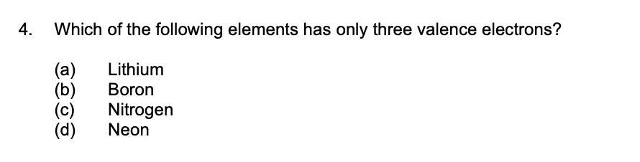

2017 S2

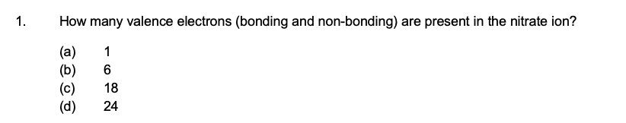

2020 S1
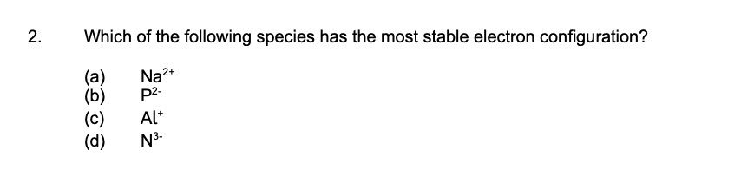
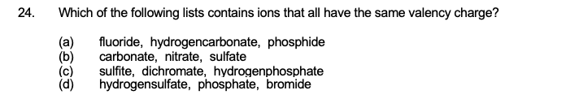

2020 S2

2023 S1
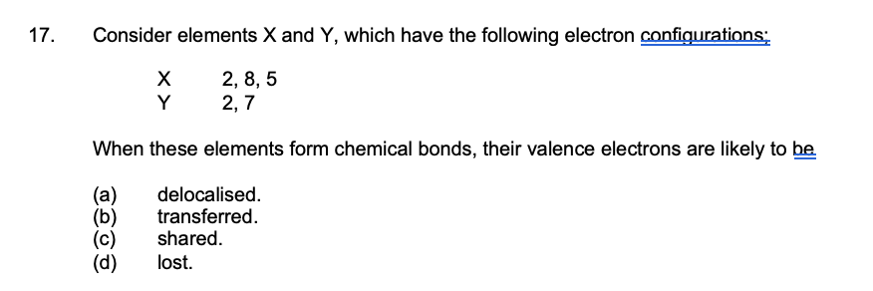

2023 S2
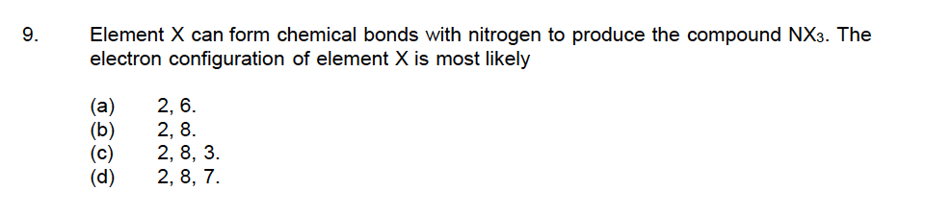

Periodic Trends – 3.2-3.3

2017 S1
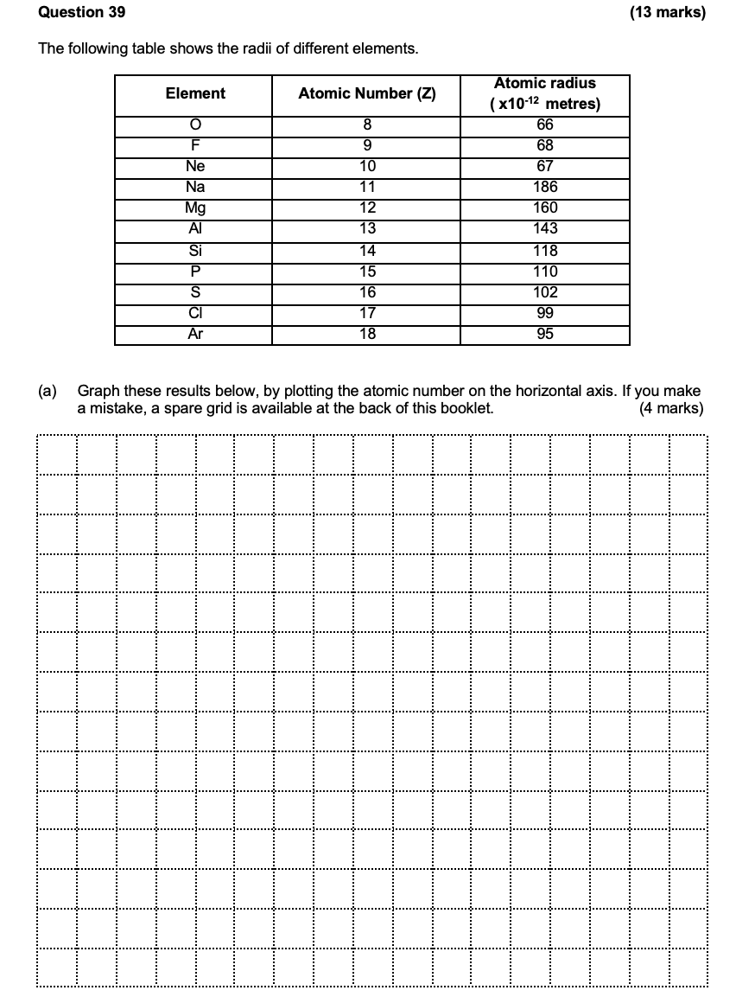
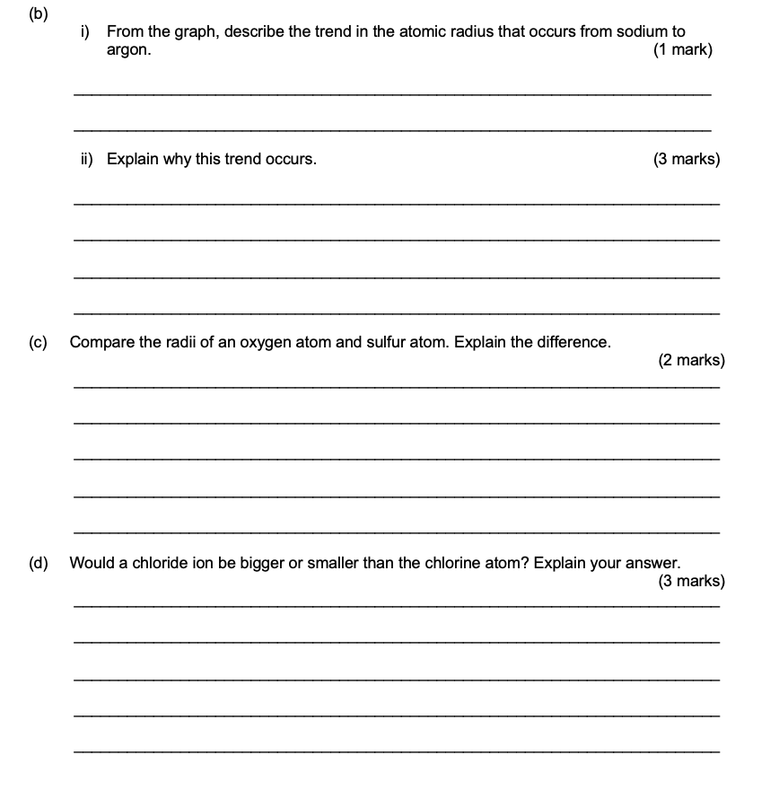

2017 S2
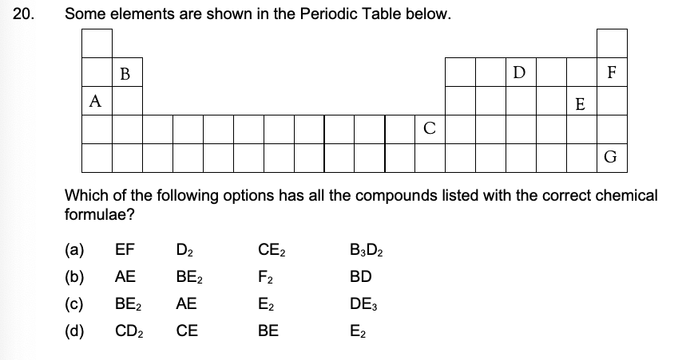

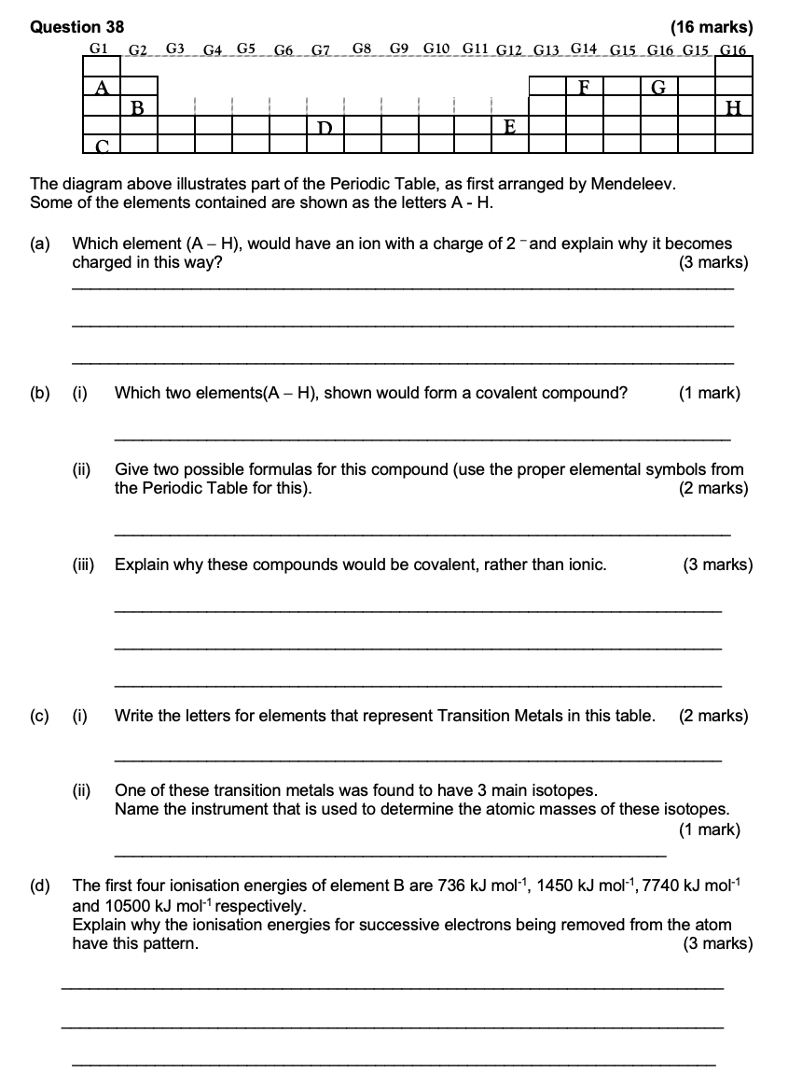
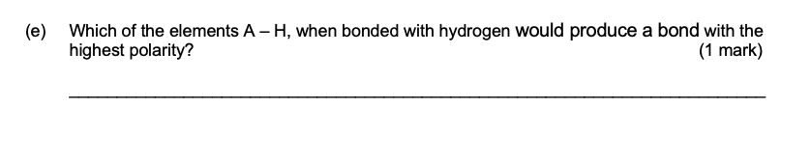
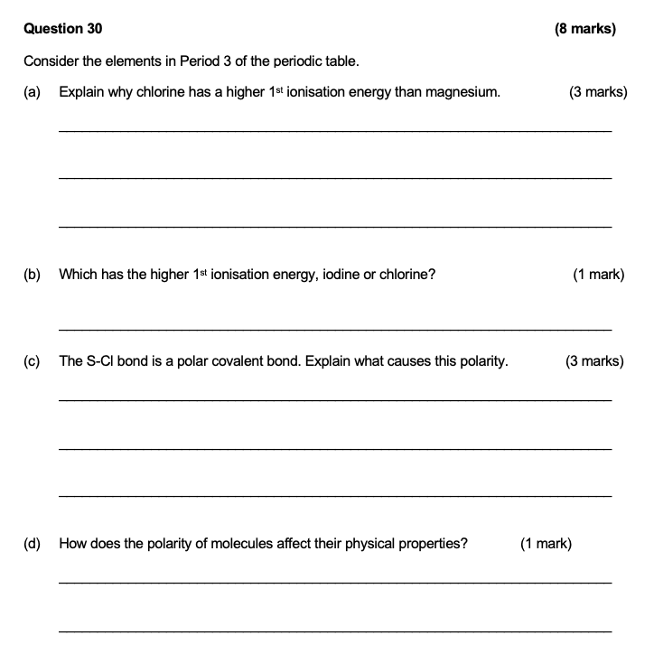

2020 S1
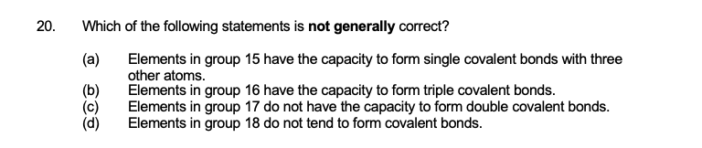
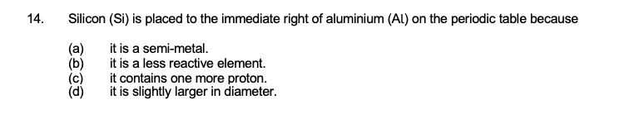
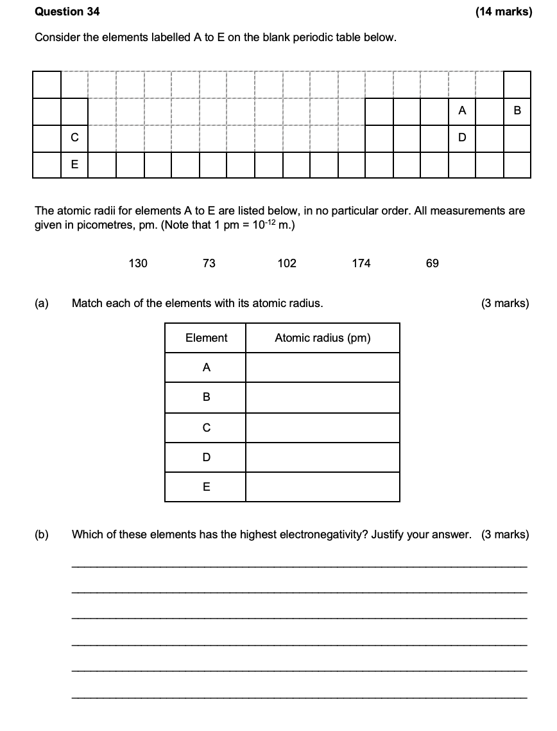
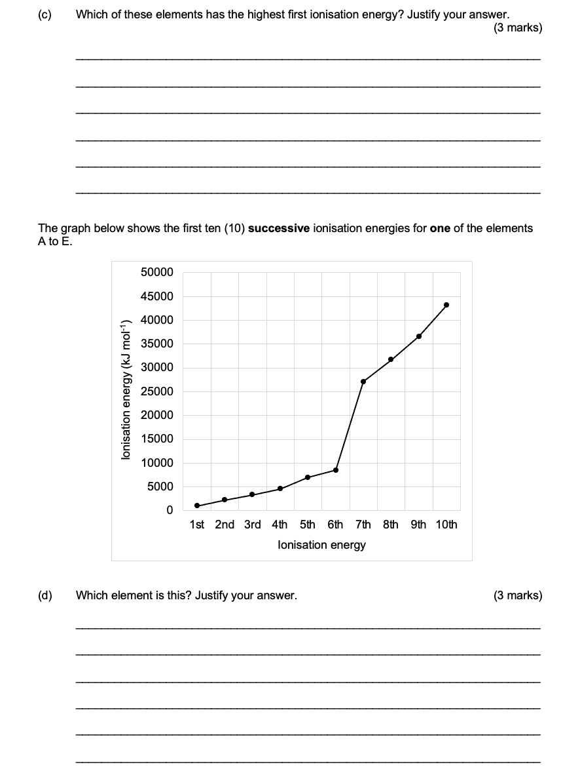

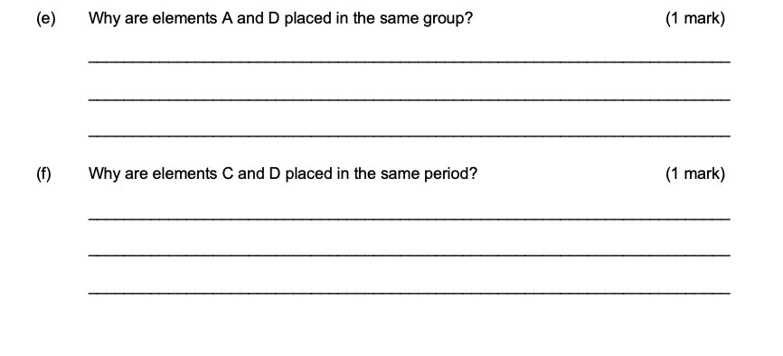

2020 S2

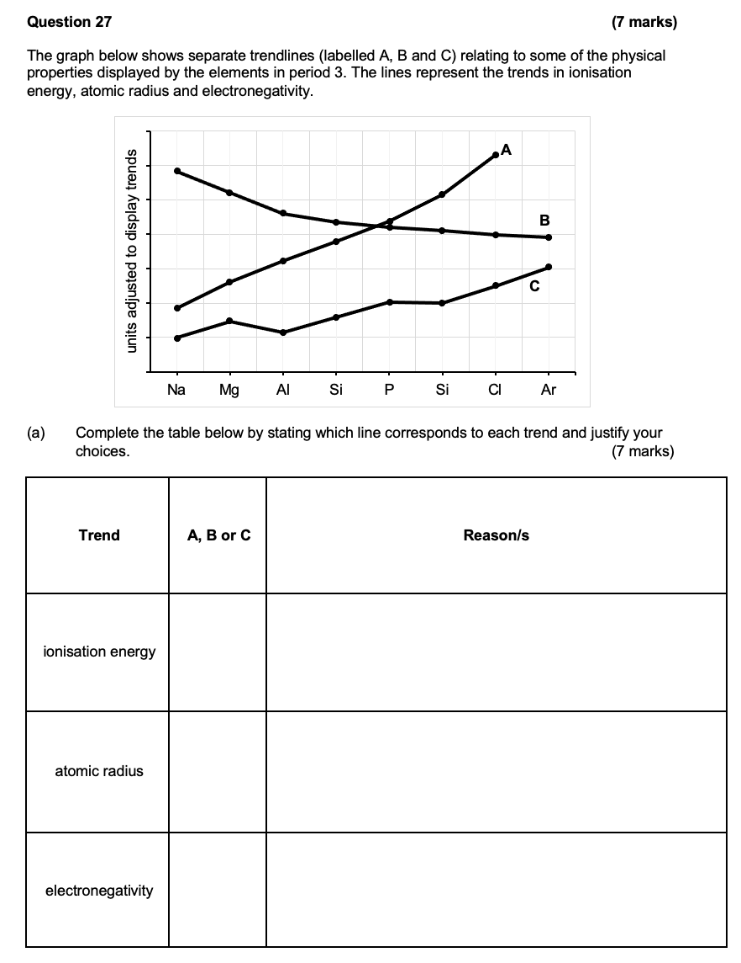

2023 S1

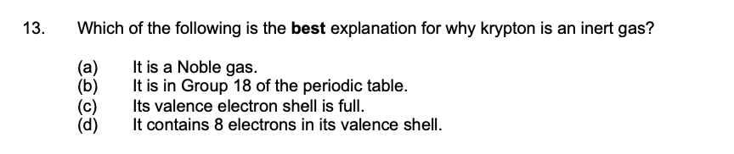
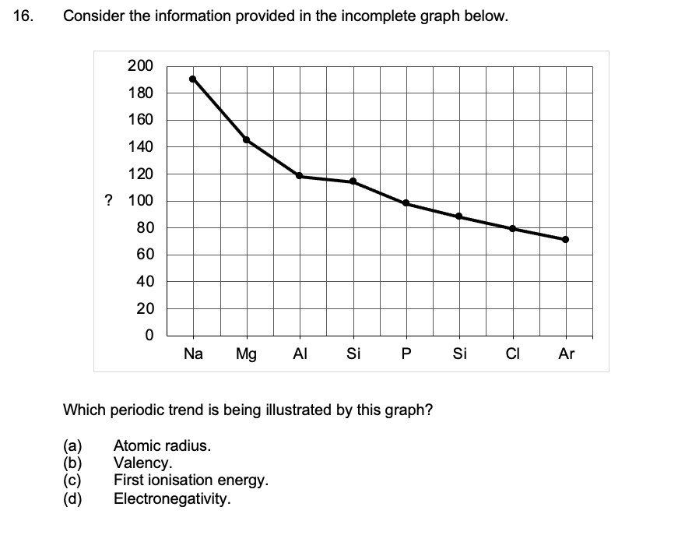
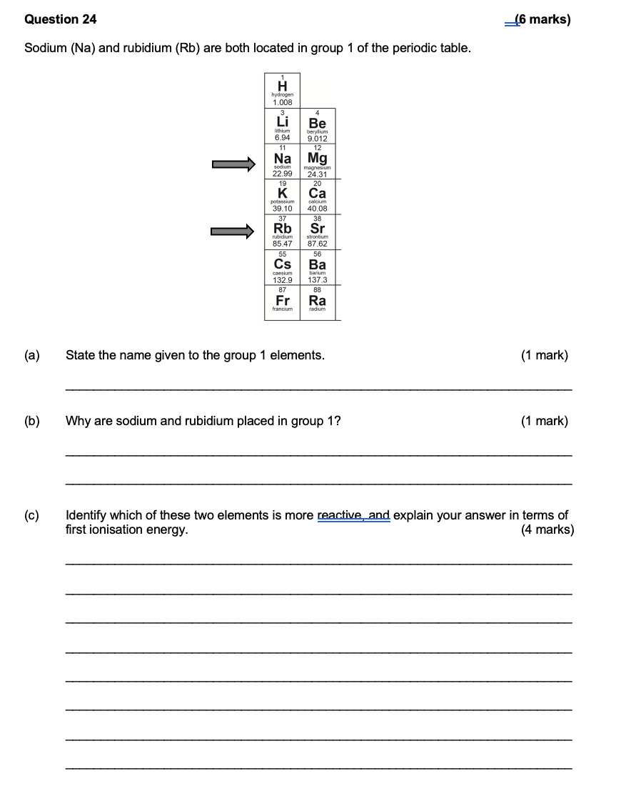

2023 S2

